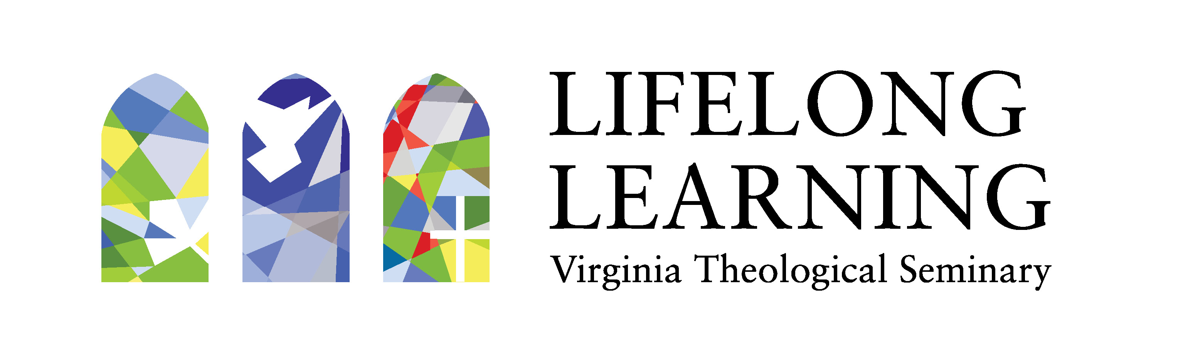

Virginia Theological Seminary (VTS) has shifted all Lifelong Learning offerings to online platforms to better equip clergy and lay leaders in this season of pandemic.

Visit our Eventbrite page for an up-to-date listing of online courses, retreats, and programs for both clergy and lay leaders. Questions? Please contact: LifelongLearning@vts.edu. Upcoming programs include:

June 3 | eFormation online conference
9:30 a.m. – 4:30 p.m. via Zoom webinars and meetings
An innovative space for leaders to grow and experiment with digital media for ministry.

June 8, 9, 10 | Deep Calls to Deep Interactive Lectures
- Monday, June 8, 7:00-8:00 p.m. via Zoom webinar
“For Those Who Preach and Those Who Hear: Crisis and Imagination” with The Very Rev. Cynthia Kittredge, Dean and President, Seminary of the Southwest
- Tuesday, June 9, 7:00-8:00 p.m. via Zoom webinar
“In My Mind's Eye: Preaching with Sanctified Imagination” with Dr. Christopher Davis, Associate Professor of Preaching and Pastoral Ministry and Associate Dean of Doctoral Studies, Memphis Theological Seminary
- Wednesday, June 10, 7:00-8:00 p.m. via Zoom webinar
“From Consolation to Hope: Announcing the Kingdom When the World is Crumbling” with The Rt. Rev. Jennifer Brooke-Davidson, Assisting Bishop, the Diocese of Virginia

June 18: The Threshing Floor: Digital & Embodied Youth Ministry Examined
3:00 p.m. via Zoom webinar
In this webinar Ethan Lowery and Tina Boyd will share from their experience in doing youth ministry beyond the church building.

June 19 | Webinar: Faith in the Future
3:00 p.m. via Zoom webinar

Author and noted futurist Bob Johansen, a distinguished fellow with the Institute for the Future, in discussion with Dr. Lisa Kimball, Associate Dean of Lifelong Learning at VTS.

